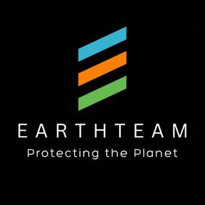

Scoring Stars

Stars can be earned on 3 levels:

- Collaborate: 1 Star (COPPER LEVEL)
- Tell us who you are and what you’re doing (or want to do) to help protect any small or big part of our planet. Tell us here [self-load link] or here [curator contact)

- Action: 5-10 Stars (SILVER LEVEL)
- See this list of actions that we reward, which follow our Theory of Change.
- Report your action and if verified, get minimum 5 Stars.
- Take time to show the effort and weight of your action, get up to 10 Stars.
- Requires 5 verifications by EarthTeam’s Verification Network, social media, or at our Monthly Town Hall meeting.

- Impact: 11-500 Stars (GOLD & PLATINUM LEVEL)
- Fill in this form to demonstrate the before-and-after picture of your intervention that helped restore biodiversity and/or mitigated climate change over 1 or more square kilometers of Earth.
- Requires 25 verifications by EarthTeam’s Verification Network, confirmed by EarthTeam’s Supreme Court.

EarthTeam Theory of Change

Today’s pressing threats to our planet’s health –pandemics, climate change, and biodiversity loss— point to common drivers and solutions.

Those common drivers include:
- commercial trade in wild animals;
- habitat destruction;
- industrial, extractive agriculture.

The common solutions include:
- ending commercial trade in wild animals;
- preserving and expanding natural habitats; and
- reforming agriculture to be regenerative.

There are many individuals and organizations working to implement these solutions. However, they are too often isolated from each other, operating in stove-pipe, or siloed fashion, which inhibits progress and threatens our planet.

In short, our planet is like a body that is under attack by various, but related diseases. But its doctors are treating those diseases in isolation, and often too late, with insufficient resources.

EarthTeam Theory of Change--

IF we can demonstrate that climate change, pandemics, biodiversity and species loss are planetary diseases that are connected, requiring holistic planetary health solutions;

IF the various stakeholders working to reverse biodiversity and species loss, climate change, prevent pandemics, and reform agriculture can coordinate and fuse their solutions;

IF those stakeholders can convince the public and private sectors that a prevention-oriented planetary health approach saves time, money, and lives;

If those stakeholders can demonstrate the benefits of these solutions through frontline models;

THEN we can scale such models and accelerate global progress* toward:
- making the planet cooler;
- increasing wildlife populations and natural habitats;
- producing healthier food that sustains agriculturalists and their lands;
- preventing pandemics.

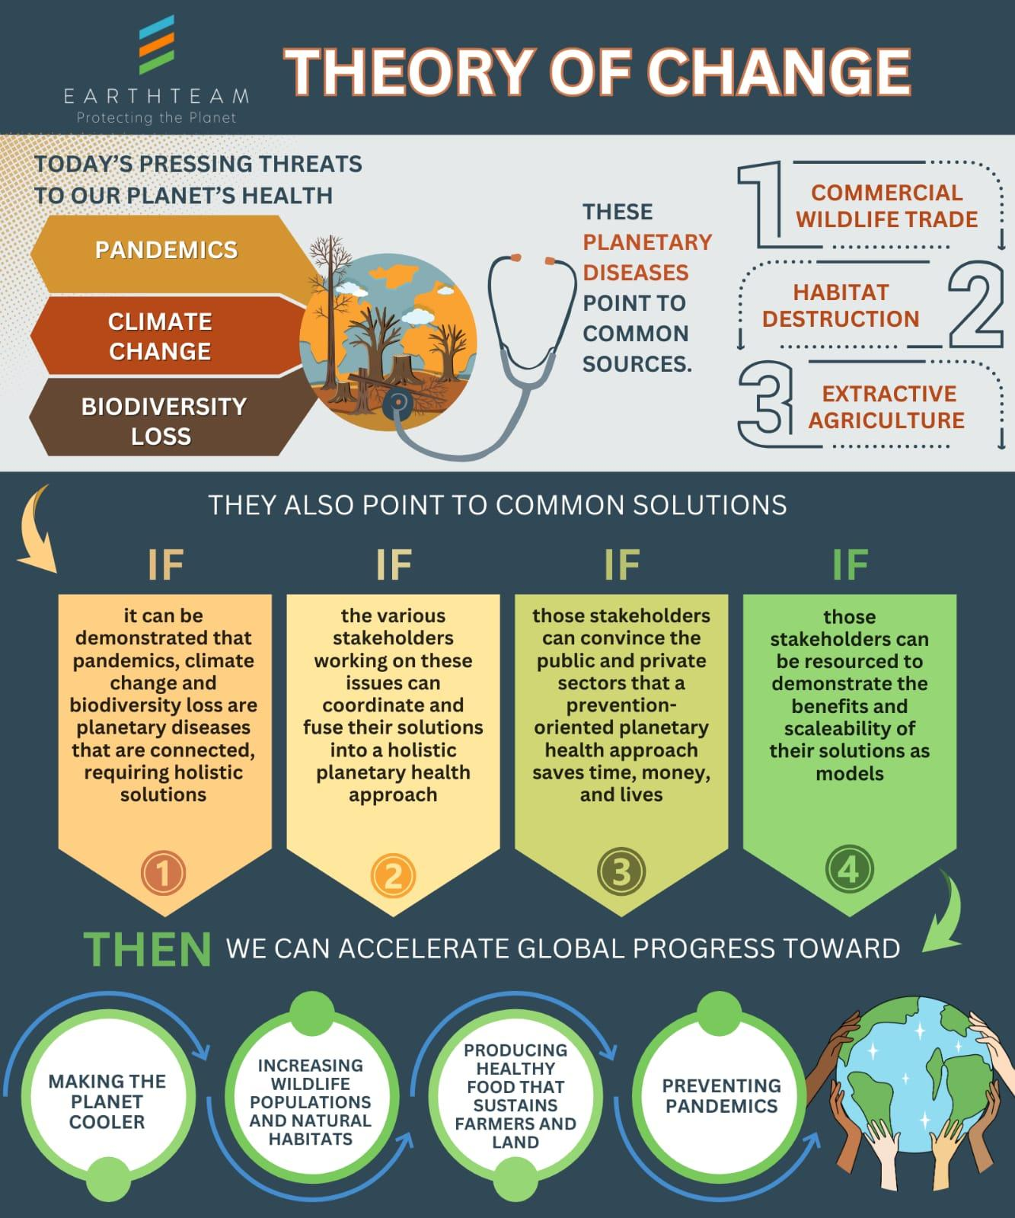

*Note: Another pressing threat to our planet –conflict—can be mitigated by cross-sectoral, transnational collaboration toward preventing environmental threats to our planet. Conflicts are often linked to competition for natural resources (land, oil, food, water, etc). Positioning stakeholders to protect their common home in the name of mutual security converts them from potential combatants to collaborators.

